Human Digestive System workshop guide

A Digestive System workshop guide is being evolved as a useful tool for the teachers , students and educators to use wonderful resources available on the internet for free in the classroom . What this guide attempts at doing is connecting the resources to the classroom through a workbook.

The Guide is organised as :
A: Resources useful for conducting the Digestive System workshop.
B: Methods that could be followed to conduct the Digestive System workshop.
C: Picture of an example of a Digestive System model made from trash.
D: Pictures of a similar workshop conducted by Science For All Foundation on Human Digestive System.

In the guide written below, we give you a complete package of conducting a Human Digestive System workshop and improve the understanding of the children .
___________________________________________________________________________________

A:The resources useful are

1.http://www.arvindguptatoys.com/toys/Humandigestivesystem.html
2.http://en.wikipedia.org/wiki/Digestion
3. The relevant textbook .(Maharashtra State - 5th Science ) {attached with this mail}
4. Everyday material as in resource 1.
5.Video in Marathi http://www.youtube.com/watch?v=5l3TDlU4c14
6.Video in english http://www.youtube.com/watch?v=eKaBQrFdNtw
7. For deeper content and understanding please refer to this video : http://www.dnatube.com/video/8362/Animation-of-the-digestive-system

Once you have seen the above videos, you will have a clearer picture about the various different parts in the Human Digestive System.

B:Following are two ways (of many) to participate in the workshop with the kids -
1. Ask the students what is digestion [forms as a pre activity assessment ]
2. Identify the different parts of the Human Body with different objects collected.
3. Brainstorm \ discuss on the design of the Human Digestive System if possible or just on the digestion model design.
{Alternative starting point} 4.Show the children the Digestive System model
5.Ask them how would they like to implement it.
6. Split them into groups . Depending on resources , groups can be
split into model , drawing on board, drawaing in notebook .
7. Ask them about Digestion [forms as a post activity assessment]

note: the pre and post assessment could be Formative or Summative . These questions will need to be formulated by the people doing the workshop .

Also , you could come up with your own method of conducting the workshop and the lesson on Human Digestive System. please let us know about it at pavan@seiglobal.in.

C: Picture of an example of a Digestive System model made from trash.
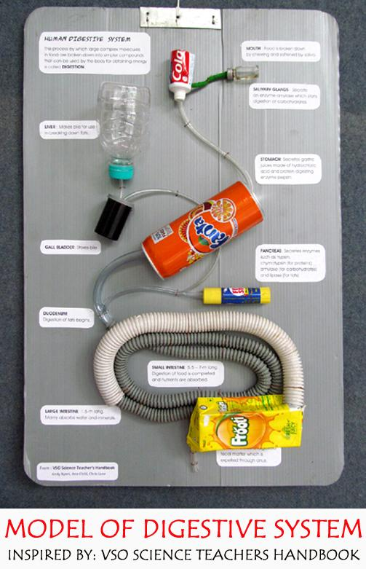
D: Pictures of a similar workshop conducted in Pune on Human Digestive System.
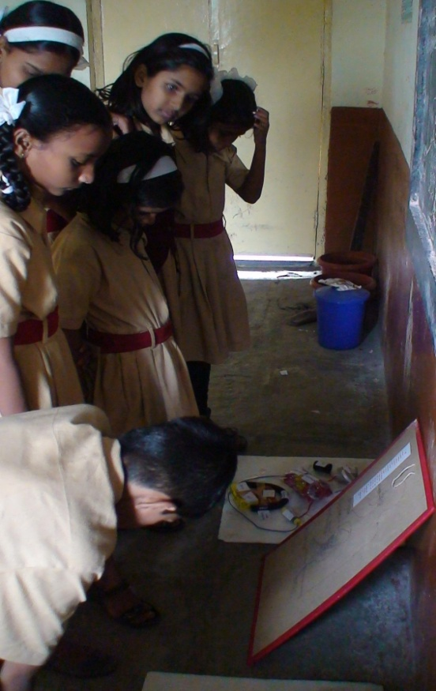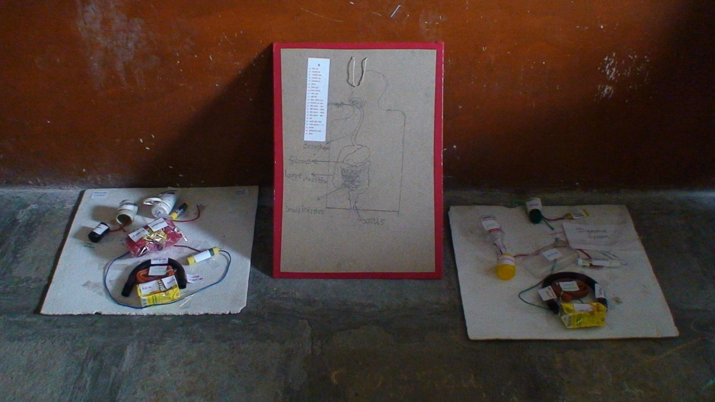
Contact Pavan Iyengar pavan@seiglobal.in .

